For solving Linear systems, mainly Gaussian Elimination is used.

**\*\*\*Gaussian Elimination\*\*\***

Create augmented matrix and select pivot points and make entries below it to be as zero.

Ball Park approximation of Gaussian Elimination if of order n^3 cost ---Highest price.

Minimum cost possible till now is N*log N

For Very large systems:

**\*\*\*LU Decomposition\*\*\***

It removes the n^3 cost of computing

A matrix can be decomposed as the sum of two matrices which are lower and upper triangular matrices.

A*x=b

LU*x=b

Ux=y

Ly=b

In solving Ly=b, it's just forward substitution solving and cost is just n^2

Similarly, in solving Ux=y, it's standard back substitution giving again cost to be n^2.

Now, to actually decompose the matrix A into LU:

Write A=I*A and in RHS, select pivot points and Convert the A in the RHS into U and I will be automatically converted into L.

LU decomposition required to be done only once and then can be stored and used over and over again for further computation and unlike Gauss. we don't need to again pay n^3 cost.

**\*Warning** : If the pivot point id zero, we have to switch rows using permutation matrices. Here the most important fact is that the permutation matrix needs to be multiplied on the both sides of equation Ax=b.

IN MATLAB, we can do LU decomposition as:

[L,U]=lu(A)

or

[L,U,P]=lu(A)

and in case P is not identity matrix, new b becomes P*b

\ command in MATLAB does:

1) Is A upper or lower triangular form? If yes, it just have to do substitution costing N^2.

2) Is A symmetric? We can do cholesky factorization and it reduces time to half of that of Gaussian ELimination.

( In cholesky elimination, the matrix A is converted into product of L*Lt. )

3) Is A Hessenberg? If yes, it writes the matrix in Upper triangular form

4) Finally it do LU decomposition.

5} If A is not square, QR algorithm is used

6) If A is not square + sparse, LSQ

Now for the matrices that are not square:

If the number of rows are greater than columns : OVERDETERMINED ( no solutions )

If the number of columns are less than rows: UNDERDETERMINED ( infinite solutions )

* In case of overdetermined, we cannot solve the Ax=b , but we can do the following: r(residual)= Ax-b and find x such that r = Min||Ax-b||. In MATLAB, we can do as:- x= pinv(A)*b where pinv stands for pseudo inverse.
* In underdetermined case, MATLAB gives the solution having minimum ||x||.

**Iterative Methods for Ax=b**

Ax=b has:

A = n*m vector

x=n*1 vector

b=n*1 vector

X may be very large n~10^8 or 9

A is often sparse ( mostly are zeros )

Example: Disease modelling

**IF A is large and sparse, then use iterative method**

**Jacobi iteration:**

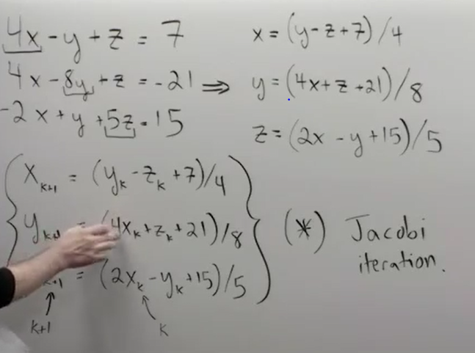

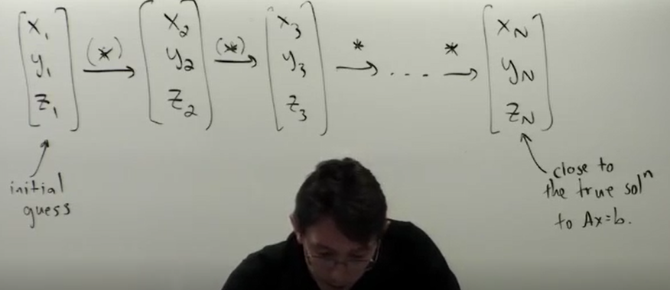

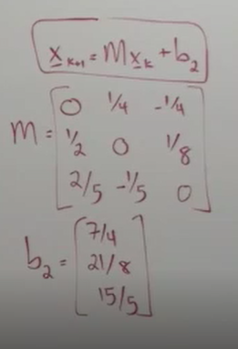

Here, Jacobi iteration method may not always work ( we can check even by swapping first and the third row of the matrix ). **The TWO important conditions for Jacobi to work is:**

1. **Strict Diagonal Dominance (SDD)** (weak condition- sufficient not necessary):

|a_kk|> Sum of off-diagonal elements of the same row of the matrix

1. Eigen values

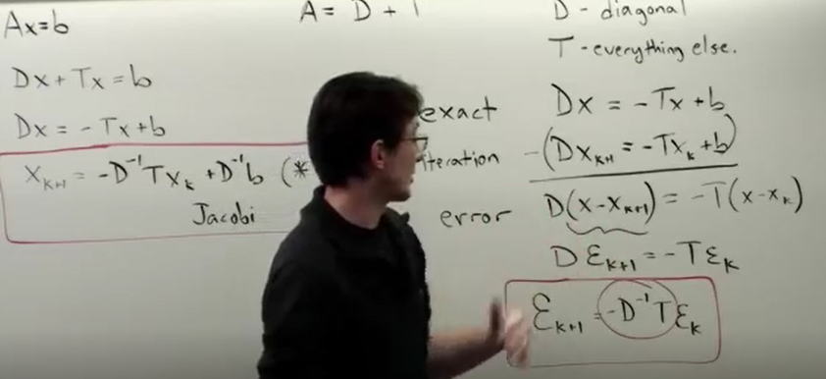

**Eigen Value and Eigen Vector**

Value of x and lambda for which A*x=(Lambda)*x , where Lambda is a scalar quantity meaning A*x and (lambda*x) points in the same direction. X which satisfies this is called Eigen Vector and Lambda for which the relation is satisfied is called eigen value.

To determine the Eigen Values and Eigen Vector:

Ax=Lx (L here stands for lambda ( characteristic value ) )

Ax=LIx

(Ax-LI)x=0

Case 1: x=0 ( not interesting )

Case 2: x is not 0 and det(A-LI)=0 meaning A-LI is singular

* Determinant A-LI =0 is a polynomial equation and the roots are Eigen values.
* After getting Eigen value plug back in eqn (A-LI)x=0 and solve for x.

A= TDT^-1 where T is the matrix containing Eigen Vectors as columns and D is the matrix containing Diagonal entries as the Eigen Values

** **IMPORTANT:**  To calculate A^n, we can calculate using following strategy which is much more cheap than matrix multiplication:

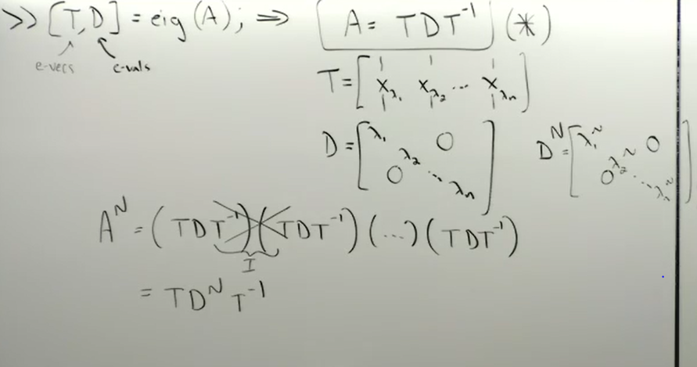

* The value of A^n can be very large or small depending on the size of the L as A^n = T*D^n*T^-1 .
* If L < 1 then L^n is tiny resulting in the small A^n
* If L > 1 then L^n is huge resulting in big A^n
* If L=1 then L^n =1

The eigen values can be imaginary as well and in that case, just the L changes to |L|.

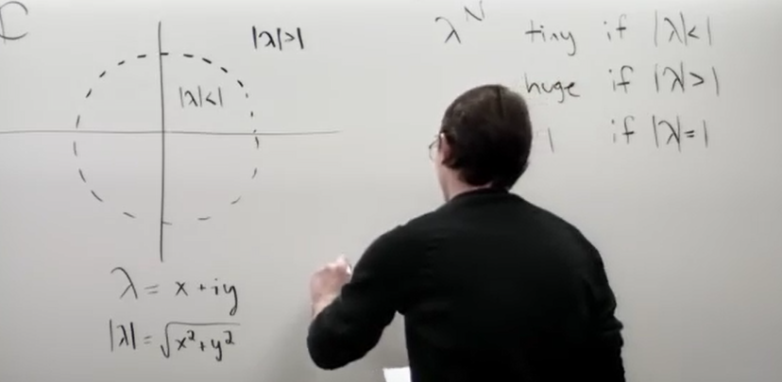

**Iterations x_k+1 = A* x_k is stable if and only if all the eig(A) are inside unit circle in the complex plane.**

The system is stable when the D^-1 * T has eigen values within the unit circle as:

Err_k+1= D^-1 *T * Err_k

**GAUSS – SEIDEL ITERATION**

It’s the enhancement of the Jacobi iteration

* It substitutes x_k+1 in the next equation rather than x_k in the next equation.

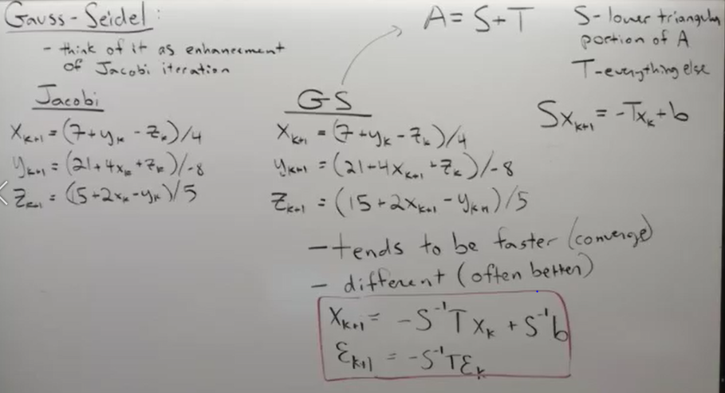

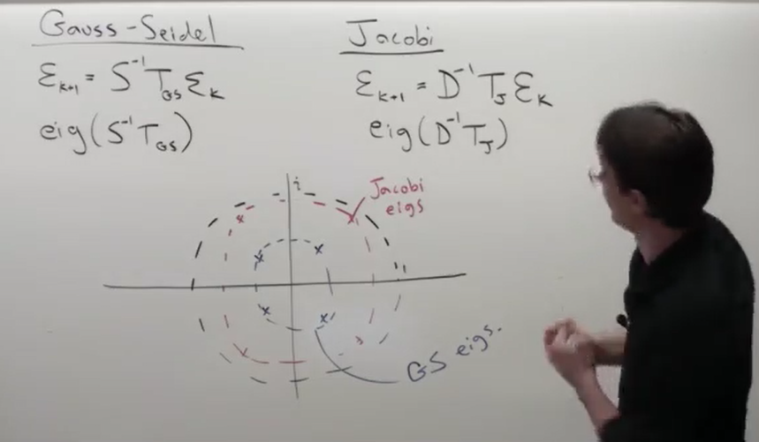’

Eigen values closer to |L|=1 are going to decay slowly than away towards 0.

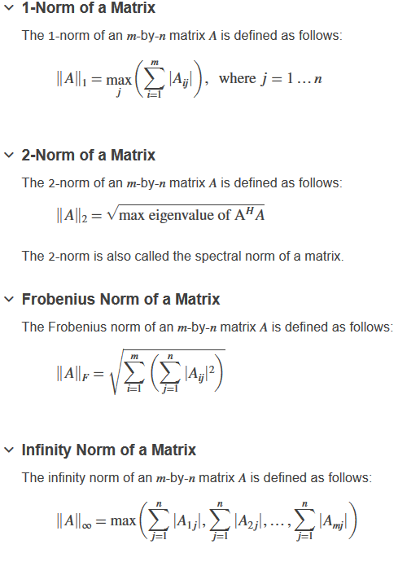

**CURVE FITTING:**

In curve fitting, the error is associated with the whole curve fitting method.

F(x) = Ax + B

F(x)= Y_k + E_k

Where E_k is the error

* Main idea is to minimize error.
* Optimization actually means :

We first calculate the maximum error and minimize it.

1. **Max Error** (Infinity error ) = max(|f(x_k) – y_k|)
2. **Average error** (L_1 error) = (1/n)* sum(|f(x_k)-y_k|)
3. **Root mean square** E_2(f) = (1/n * sum(|f(x_k)-y_k|)^2)^0.5

Least Square Fit

**In minimizing the error, IMP point to notice is that the derivative=0 ensures that the minimum exists as the maximum for such curve fitting cases does not exists as the curve can be as far as possible and extends to infinity, thereby maxima for such cases does not exists.**

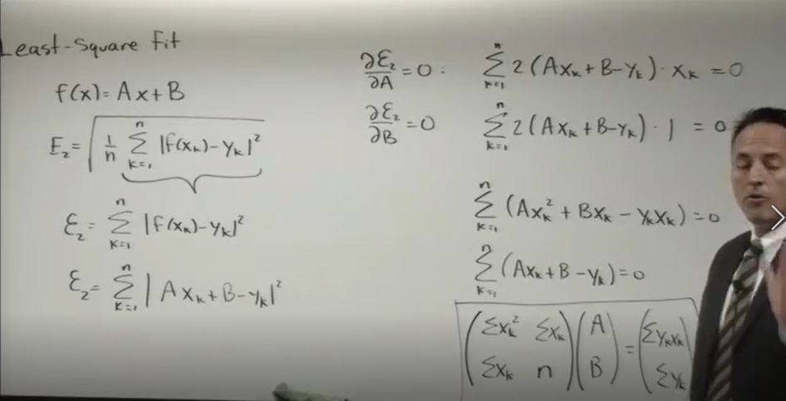

At the end, the least square fit methods comes out to be solving linear system only.

To fit polynomials rather than the line :

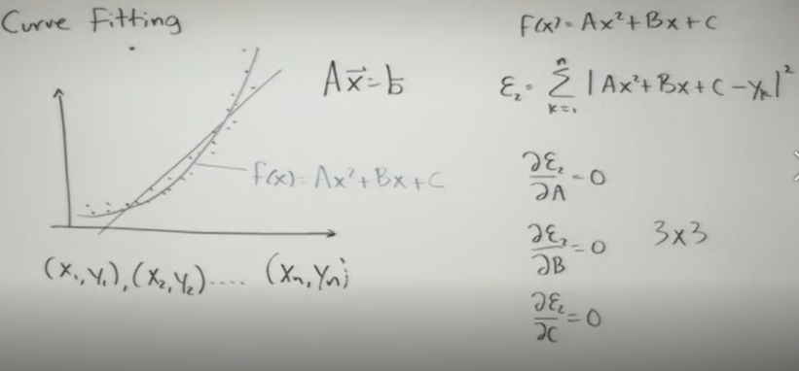

In case of the curve fitting by functions other than the polynomial functions, the result might be ending up with the non-linear systems. Non linear systems could not be solved with the simple Ax=b case and neither it has fixed number of solutions and not a proper systematic way of approaching such problems.

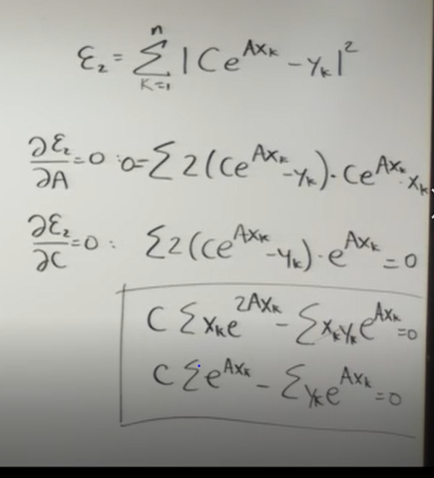

In some of the non-linear functions, we can do data linearization:

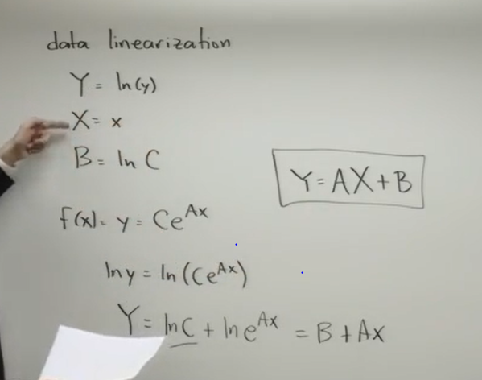

At the end, we can do linear fit.

General problem solving is:

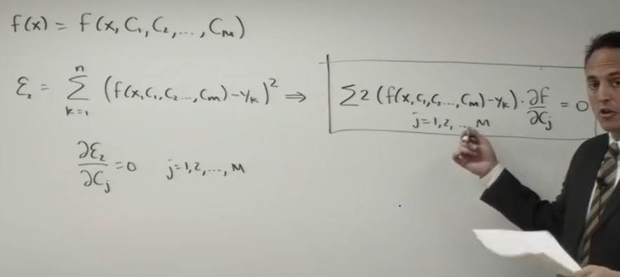

Curve fitting is used to interpolate or extrapolate to get the data at the points at which the data is even not available.

If we want error to be zero, i.e., we evaluate the polynomial passing through the all points by having n+1 by n+1 system of equation.

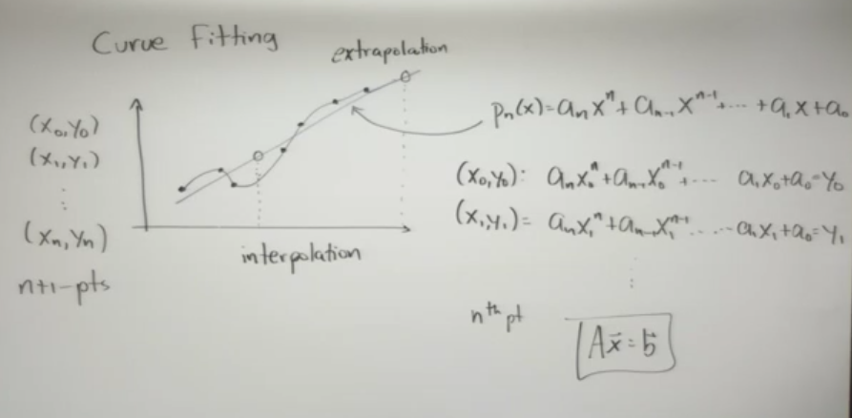

MATLAB **does lagrange polynomials** :

We have :

L is called the Lagrange coefficients.

* We can directly find the polynomial directly
* 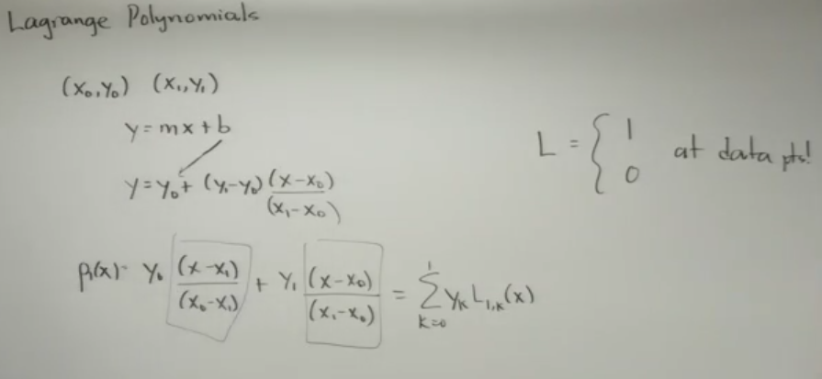
* Lagrange coefficient formula is :
* 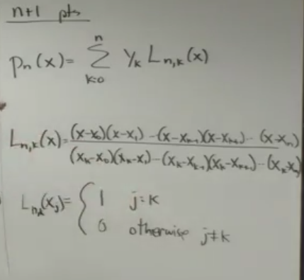
* Writing for n+1 points giving out nth degree polynomial

Drawback of polynomial fit:

For 21 points, the polynomial will be of 20th degree and will have 19 turns (maximas and minimas) . Some **POLYNOMIAL WIGGLES** takes place leading to the inappropriate interpolations.

**SPLINES**

Splines look in between the two points and construct the cubic polynomial for each interval.

The curve is smooth all over, hence the first and the second derivative match at the points

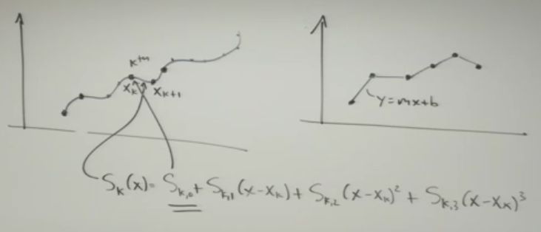

There are infinite number of splines possible for the given set of data points.

We have to impose 2 more conditions on the first and the last point to match the number of unknowns and the number of constraints.

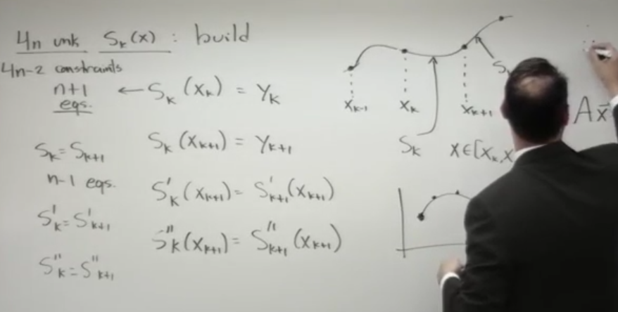

**GAUSSIAN FUNCTION\*\*\***

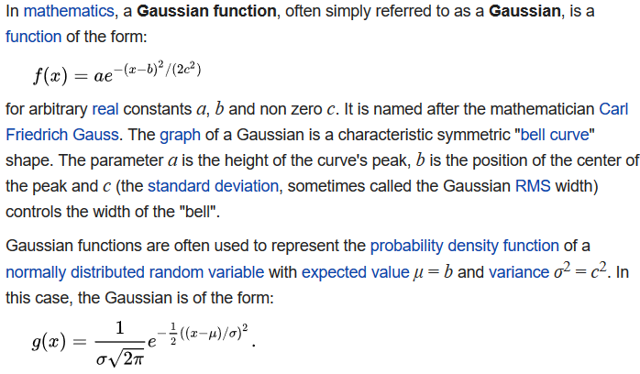

**FUNCTION HANDLES**

F=@(x) sin(x)

**FMINSEARCH**

**OPTIMIZATION**

Objective function is the function which we have to minimize or maximize

* Feasibility
* Constrained vs uconstrained

Functions depend on the variables which we can change to optimize the function – **Control Variables**

**GOLDEN SECTION SEARCH (Derivative Free method)**

F(x)- unimodal means that the function has single minima or local minima

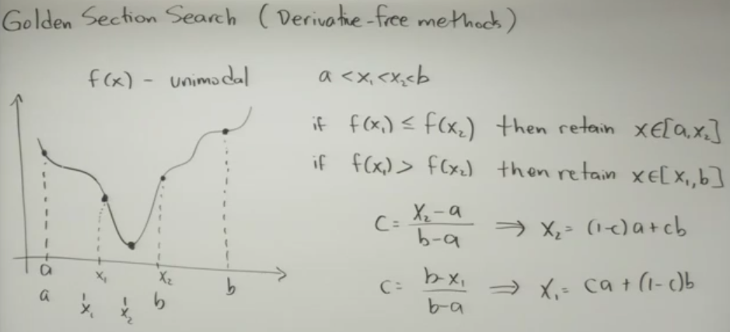

C is the reduction factor

If we have c, we can get x1 and x2.

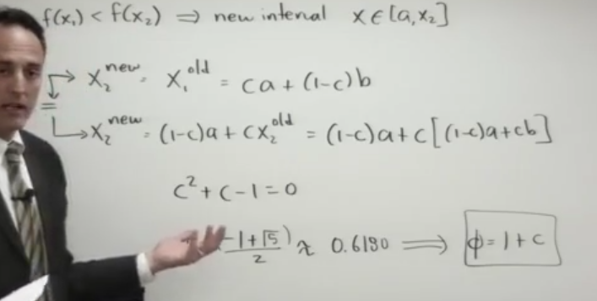

We recycle points to get the new x1 and x2.

Phi in the above figure is called the golden ratio.

**SUCCESSIVE PARABOLIC INTERPOLATION (DERIVATIVE FREE METHOD)**

Derivative free method is useful as it does not look at the function form and evaluates just the value of the function at some of the specified points.

Taking three points on the curve, draw the parabola whose equation can be found using the lagrange formula and find the point at which the parabola value is minimum as shown:

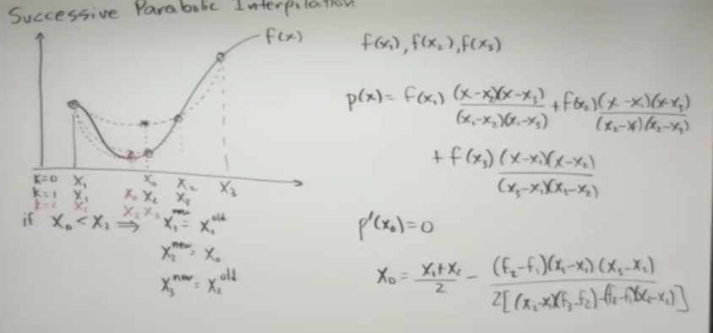

We make successive parabolas and finally the minimum of the parabola and the given curve coincide .

**ERROR: The formula given for the calculating the minima is WRONG ! Plz refer practise m file for correct one.**

**FMINBD (MATLAB BUILT-IN FUNCTION)**

The command is used to find the minimum using a combination of the successive parabola interpolation and the golden section search.

**DERIVATIVE BASED METHODS OR UNCONSTRAINED OPTIMIZATION**

To find the minima of the function, we have to set the gradient to be equal to zero.

Methodology is also called **Gradient descent** .

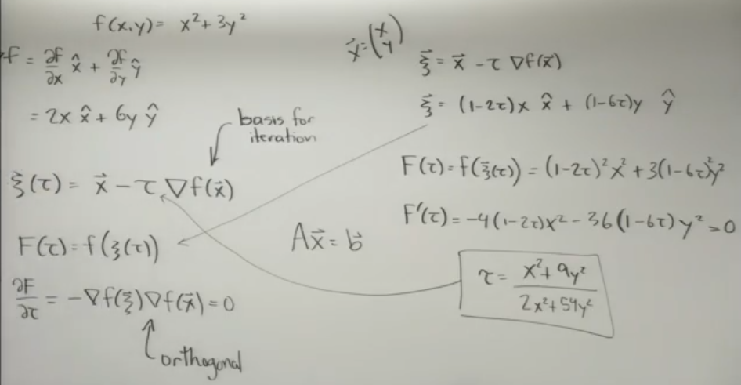

**Linear Programming**

It’s applied to linear problems within contsraints

C tells about the weighting of each components of the vector X to minimize

X0 is the initial guess

Linprog command in MATLAB is used to do linear programming directly.

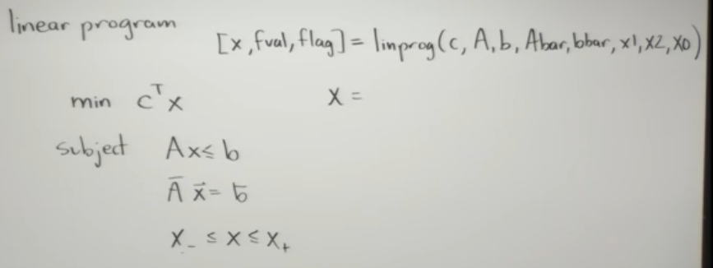

Example done in linear_prog.m file is:

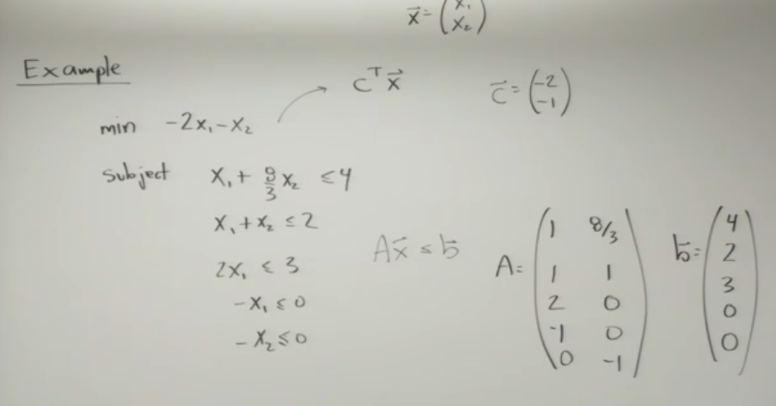

**Genetic Algorithm**

Solves the very complex non-linear programs when linearity and convexity does not work

How it works:

* Guess randomly a bunch of vectors and check out how it does with the objective function
* Keep the best p guesses out of m total guesses and discard the rest
* In these bunch of p guesses, each one is mutated into p-1 other mutants by little perturbing each one of them. Now, We have again p guesses for each p selected guesses.
* Now, plug the new whole bunch of the guesses into the objective function and again select p out of the bunch.
* Repeat the procedure until the guesses converge

MATLAB function for the genetic algorithm is:

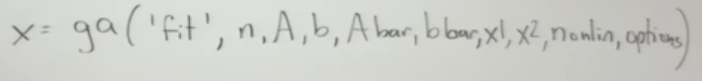

**NUMERICAL DIFFERENTIATION AND INTEGRATION**

Derivative gives the slope of the function at that point.

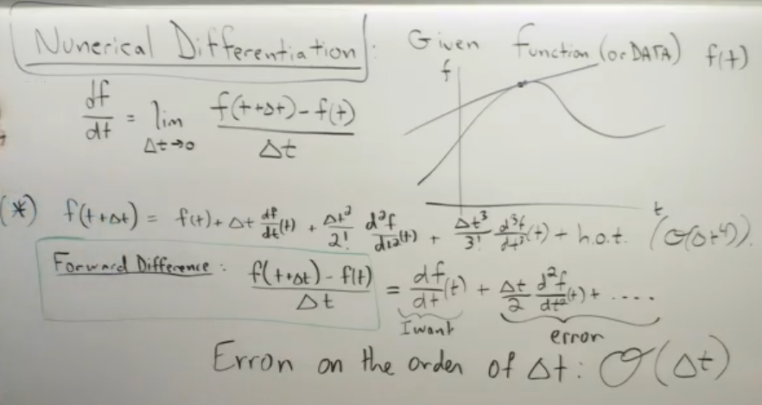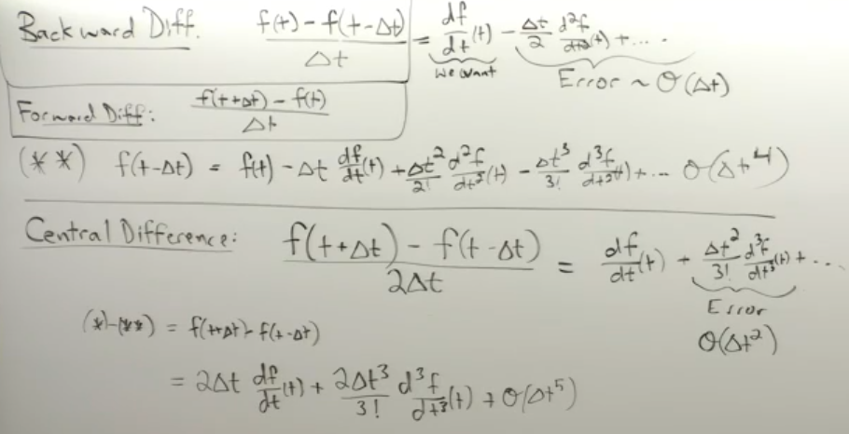

The central difference is the best amongst all the available options as it has error of the order of delta t squared and the others have error of the order of delta t.

Central difference method is not possible in case of:

* the real time problems as we don’t have acces to f(t+delta t) as it hasn’t happened yet
* When computing at the boundaries
* As the delta t tends to zero, the error does not become arbitrary small because of the numerical truncation error.

Current machine has round off error is nearly 10^-16 (for double precision). Thus, for machine, 10^-16 / 2 is same as 10^-16. And on decreasing the delta t, the error in fact increases.

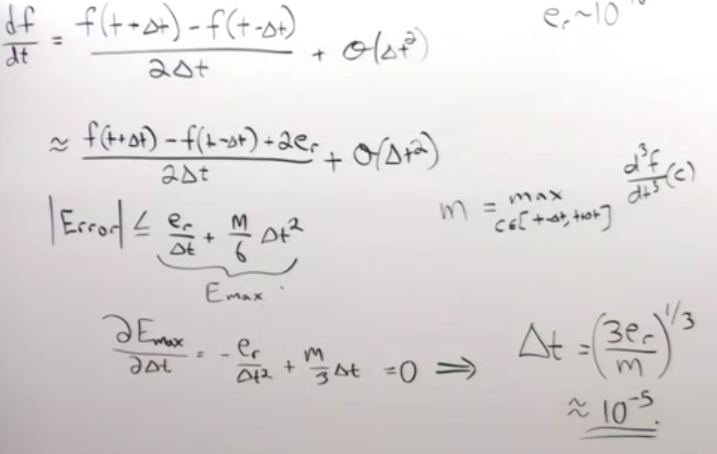

**Numerical Integration**

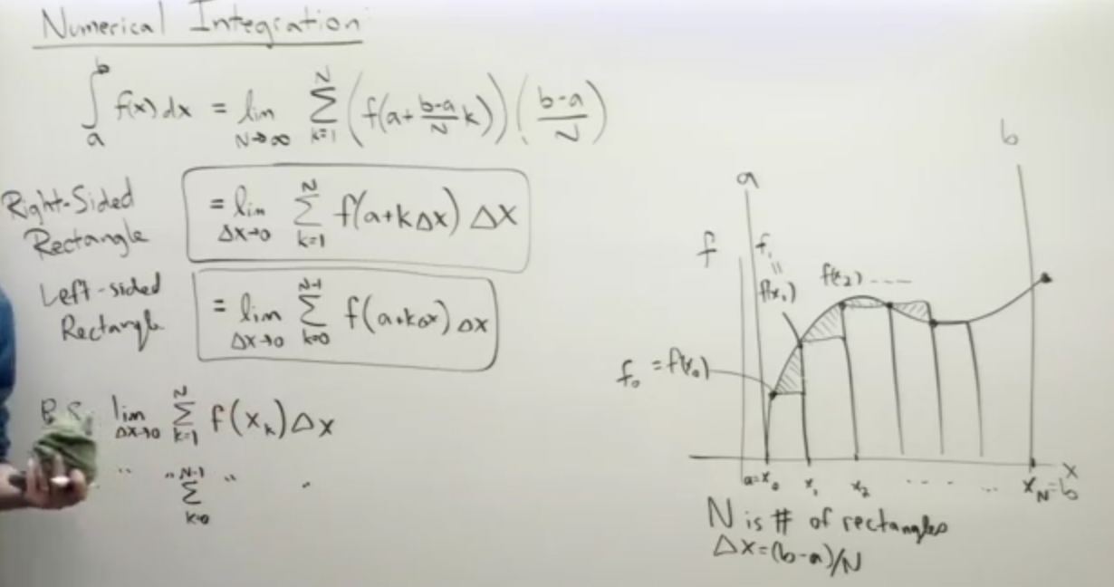

ERROR ANALYSIS OF NUMERICAL INTEGRATION

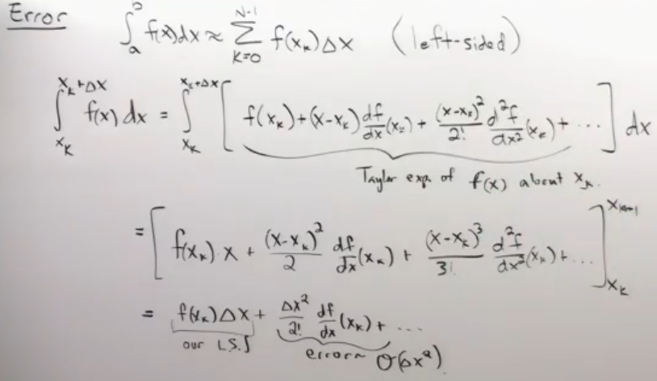

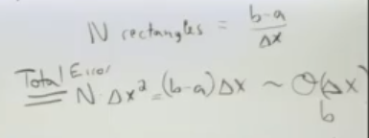

**TRAPEZOIDAL INTEGRATION RULE**

Trapezoidal rule still gives the error in case of very high curvature, that is, the second order

Derivative is very large.

We can use MATLAB command trapz(x,y) function to find the area in the x,y plot using

Trapezoidal rule.

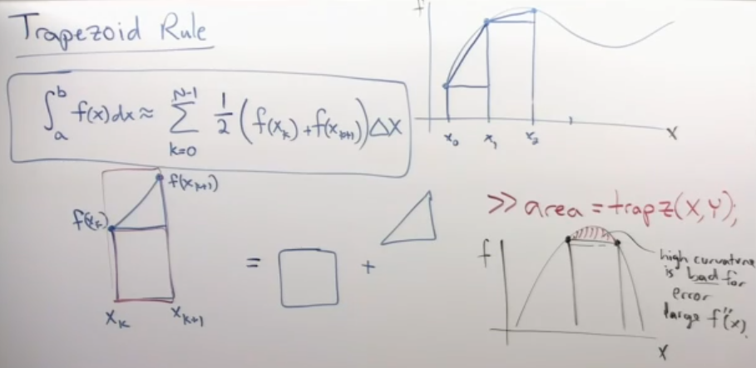

Since, the trapezoids share point (consecutive ones ) and hence evaluating the function valu

-es can be expensive, So, we follow the following rule:

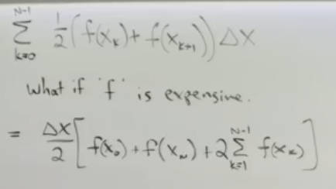

**SIMPSONS RULE**

It is based on the cubic spline interpolation. And having the least error

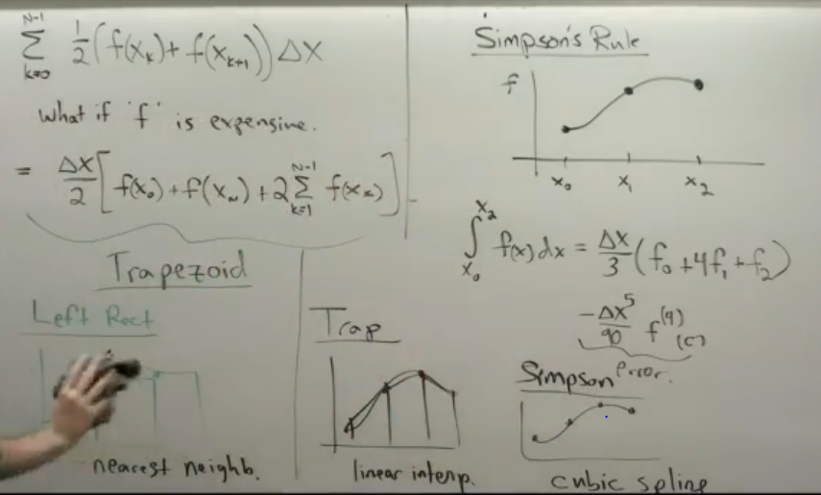

**ORDINARY DIFFERENTIAL EQUATION**

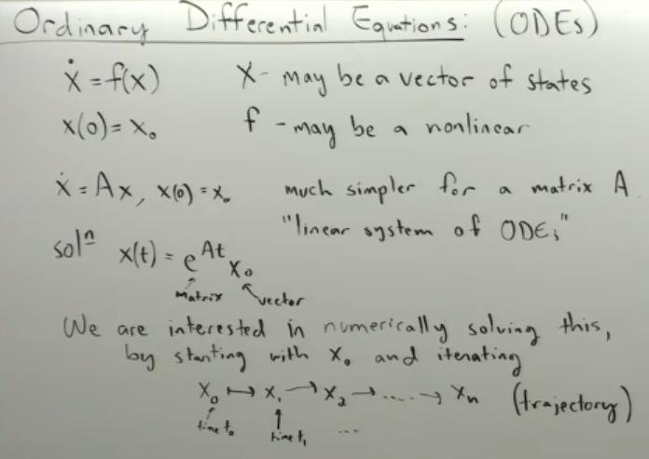

Methods to solve ODE are:

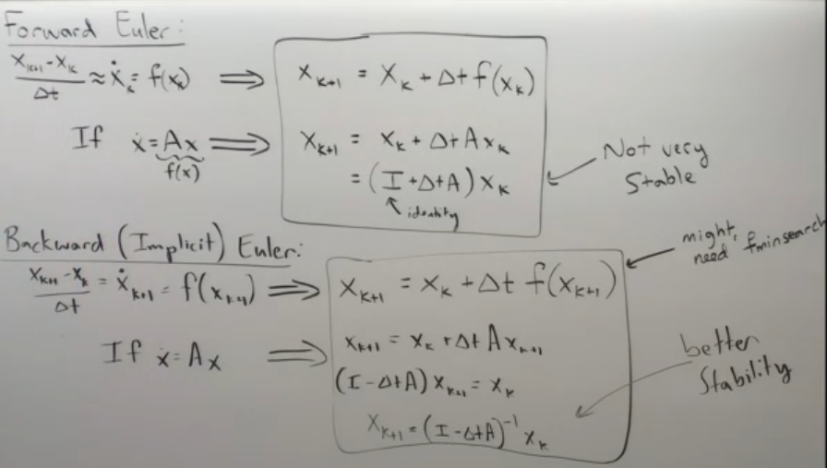

In Backward Euler, we don’t know the value of the function at the k+1 position hence, we have to

Implicitly solve the equation for it. This could be complex sometimes, but this method is more stable than Forward Euler.

ANALYTIC SOLUTION TO SPRING-MASS-DAMPER SYSTEM:

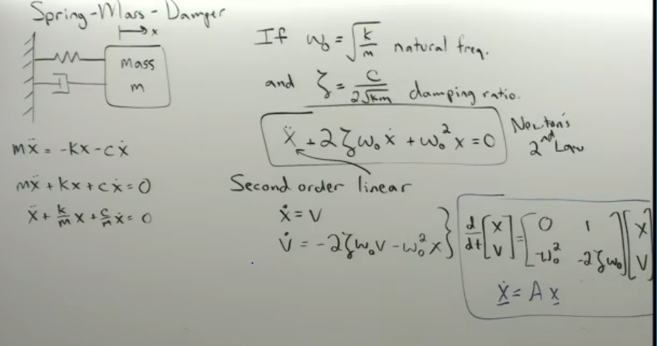

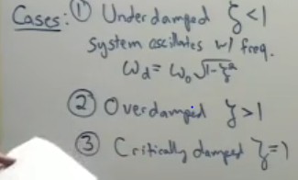

**Error Properties:**

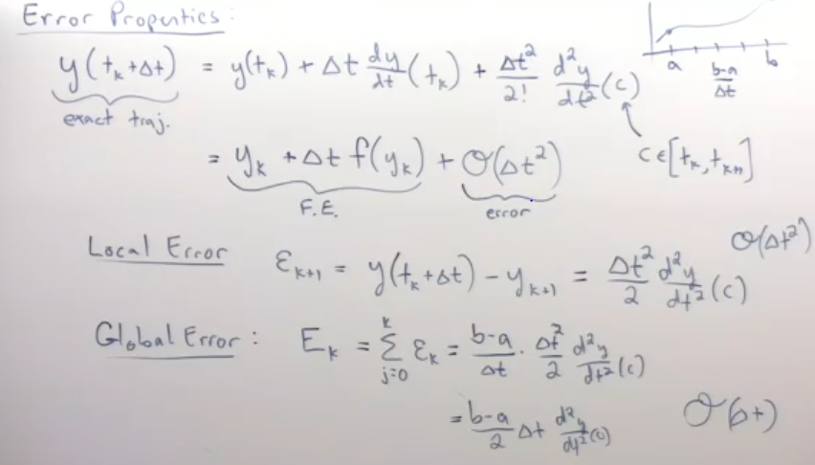

**Stability of the numerical method:**

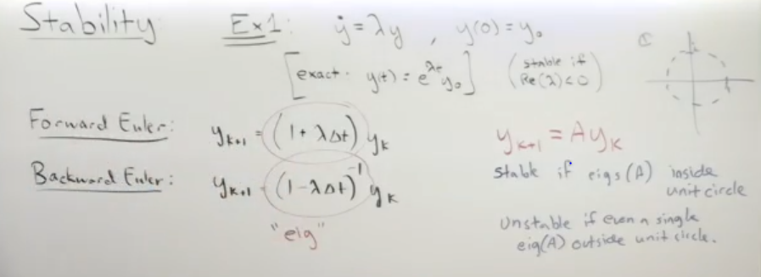

For scalar quantities, the eigen values are the the numbers itself.

Forward euler scheme is much less stable than the backward euler schemes.

For scalar lambda:

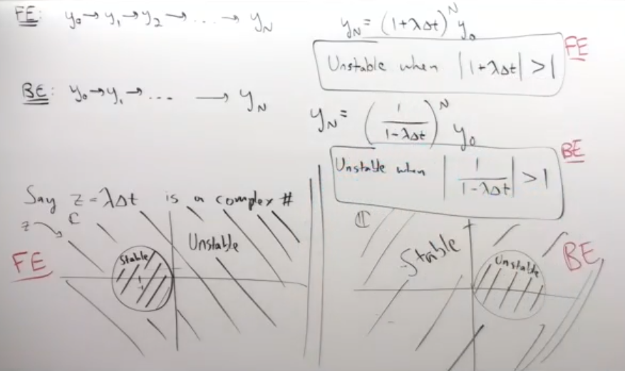

For matrices A:

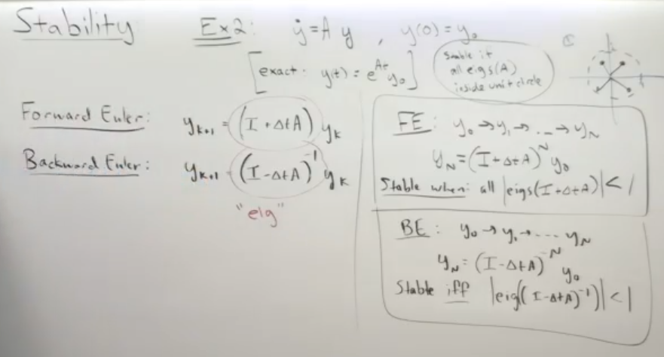

FE stands for forward euler and BE stands for backward euler.

To get through the RUNGE KUTTA METHODS BASIC DERIVATION:

Read Lecture 7_3 . Crux is:

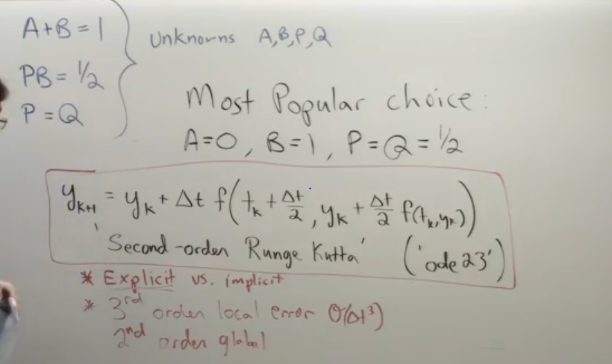

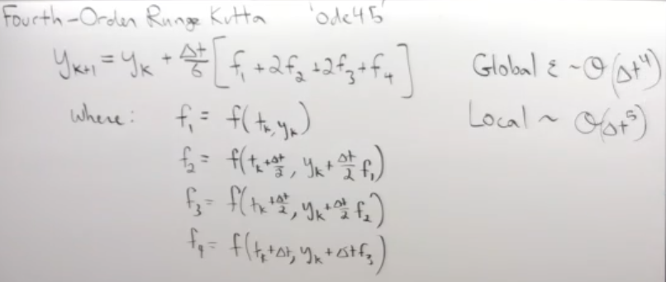

Adams –Bashforth integrator is used majorly for the fluid flows.

Stiff integrators – where different time steps are required at different places

Energy conserving (Simplectic)

**Lorenz chaos theory:**

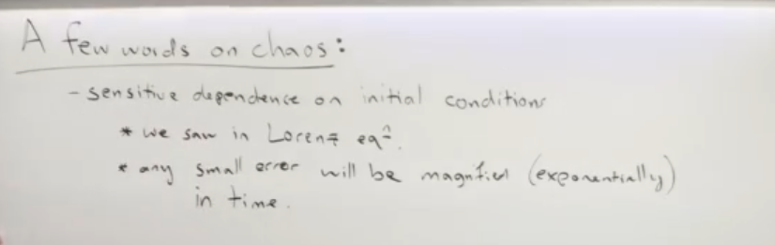

**Chaos is sensitive to initial conditions**

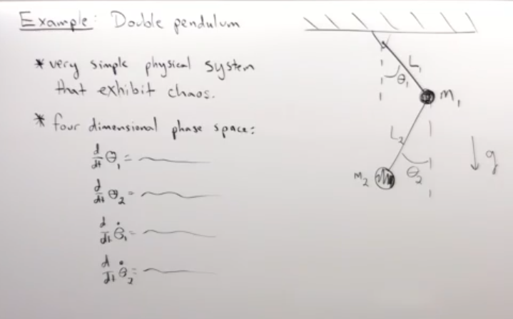

**SINGULAR VALUE DECOMPOSITION**

In linear algebra, A*x gives another vector. A actually does just rotation and stretching only.

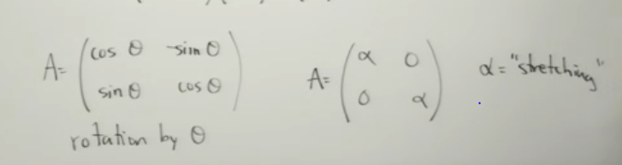

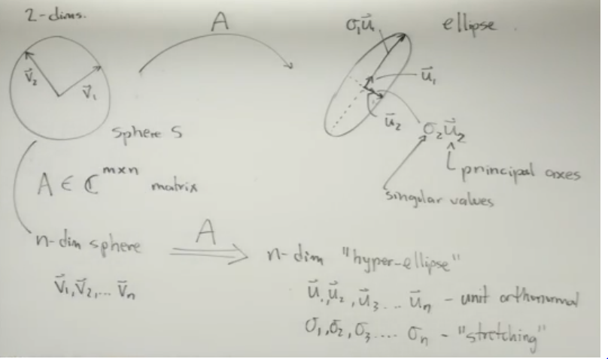

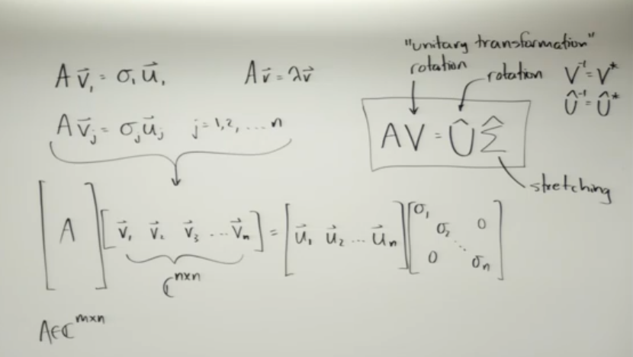

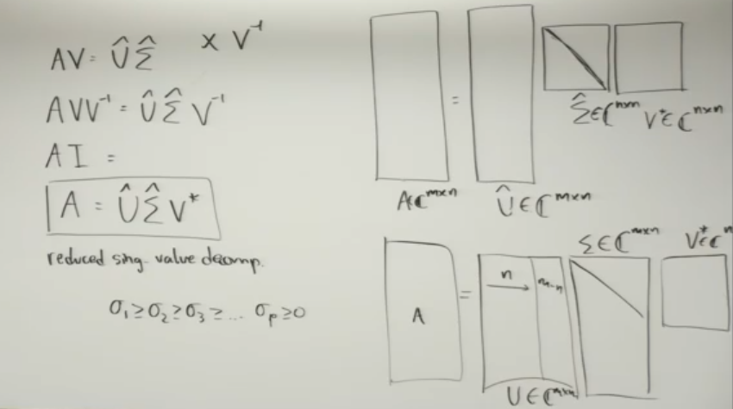

**Important Theorem:**

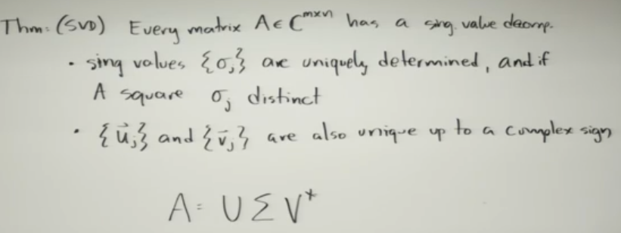

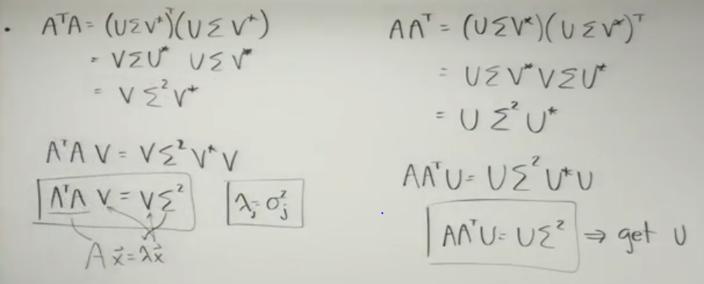

**Now,** is it possible to derive the equation of motion from the observation using the camera data.

**VARIANCE AND COVARIANCE:**

* Sigma a and sigma b is known as the variance.
* Variance basically tells that how large the changes in the data are.
* Covariance (sigma ab) tells how much a and b are in the same direction. (Basically the dot product )
* If a and b are in perpendicular direction, they are called to be statistically independent and if a and b are in the same direction, they are known as statistically dependent.
* 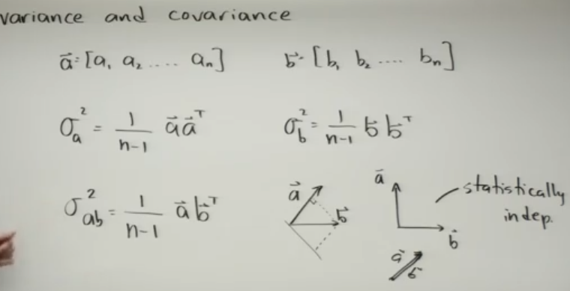

**Cx**  is the covariance matrix .

* Diagonals measures the variance
* Off diagonals measures the covariance and are symmetric, self adjoint and hermitian
* If the covariance is very small, it means that its statistically independent
* If the covariance is big, then they are statistically dependent.
* MATLAB command to do the same is the cov(X)

**MAIN OBJECTIVE: To make the covariance matrix to be diagonal which implies no redundancies.**

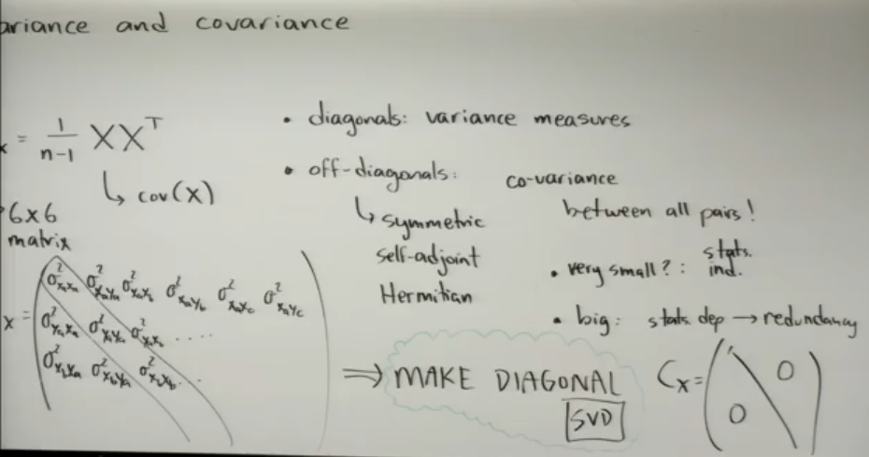

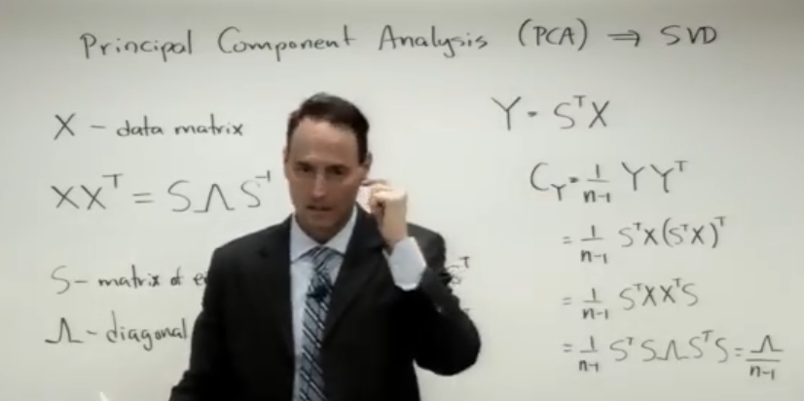

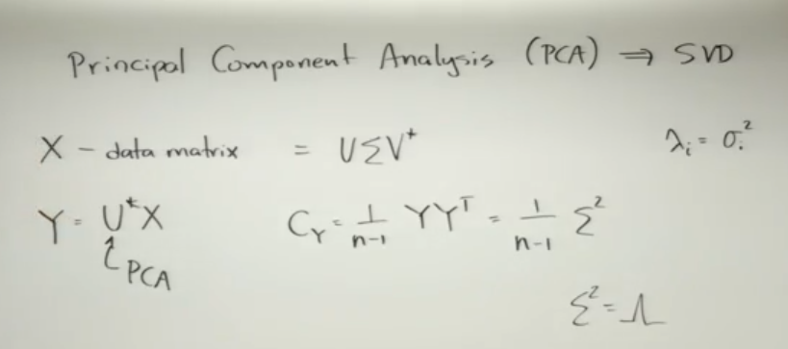

Each image acts as the data matrix with each pixel containing data points.

We take the image and break up into the row vector.

